272-[DF]-Lab - Working with Functions
Query the world database
The following query demonstrates how to use aggregate functions SUM(), MIN(), MAX(), and AVG() to summarize data.
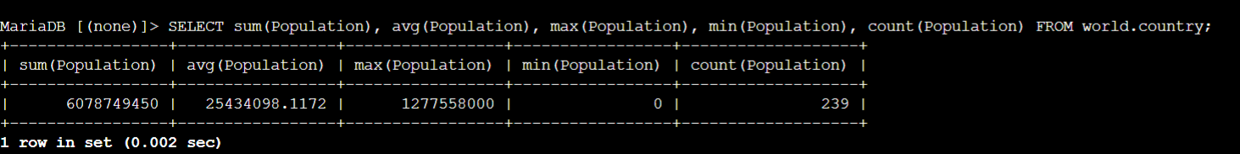
In some cases, you might need to split a string. The following query uses SUBSTRING_FUNCTION() to spilt a string where a space occurs.
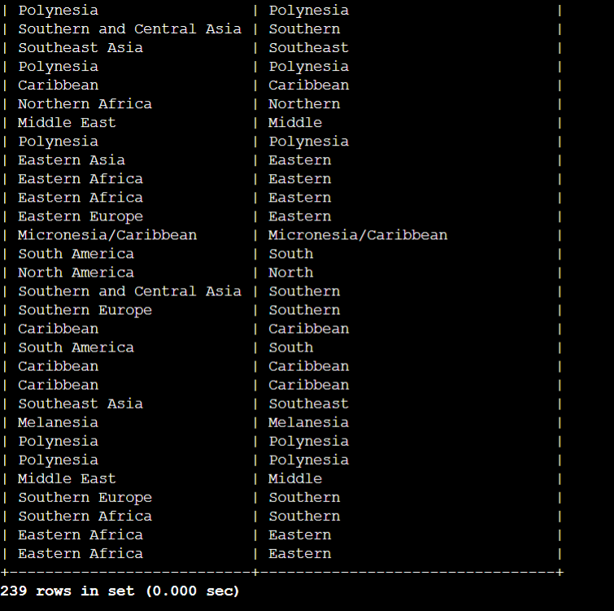
Sometimes you may need to search rows using a string fragment. The following query includes SUBSTRING_FUNCTION() as part of a condition in the WHERE clause to filter records that include Southern in the first part of the region name.
